Clarins: Elevating skincare and beauty with botanical expertise and innovation.

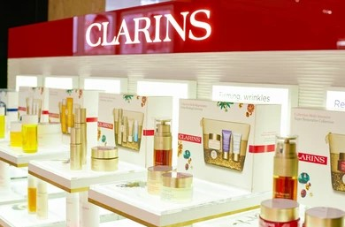

Clarins, a French skincare brand renowned for its botanical-based solutions, offers premium beauty products crafted with over 60 years of expertise. Experience the fusion of natural ingredients and cutting-edge innovation for radiant, healthy-looking skin.

SUBMITED BY

Shah Muhammad Siddiqui---( Student1528119)

Of batch **PR2-202310B1** have successfully completed the given task for the topic

**FACULTY: SIR SHAHBUDDIN**

SEMESTER---CPISM

APTECH LEARNING SHAHRAH-E-FAISAL

**INTRODUCTION**

Clarins, a French skincare powerhouse with over 60 years of industry experience, epitomizes excellence in natural beauty solutions. From its origins as a beauty spa, Clarins has evolved into a trusted brand offering a diverse range of skincare, makeup, and fragrance products.

Driven by a passion for authentic beauty, Clarins combines skincare science with botanical expertise to create products that deliver unparalleled efficacy. With a focus on holistic beauty, Clarins offerings provide both visible results and a sensory experience.

Beyond its own product line, Clarins curates a selection of offerings from various brands, ensuring a comprehensive skincare solution for customers. With a commitment to excellence and innovation, Clarins continues to lead the way in premium skincare, offering a pathway to radiant, healthy-looking skin.

**ACKNOWLEDGE**

The thirst for learning, upgrading technical skills and applying the concepts in real life environment at a fast pace is what the industry demands from IT professionals today. However busy work schedules, far-flung locations, unavailability of convenient time-slots pose as major barriers when it comes to applying the concepts into realism. And hence the need to look out for alternative means of implementation in the form of laddered approach. The above truly pose as constraints especially for our students too! With their busy schedules, it is indeed difficult for our students to keep up with the genuine and constant need for integrated application which can be seen live especially so in the field of IT education where technology can change on the spur of a moment. Well, technology does come to our rescue at such times!! Keeping the above in mind and in tune with our constant endeavour to use technology in our training model, we at Aptech have thought of revolutionizing the way our students learn and implement the concepts using tools themselves by providing a live and synchronous e-Project learning environment!

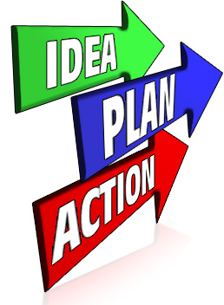

**WHAT IS THIS E-PROJECT?**

E-Project is a step-by-step learning environment that closely simulates the classroom and Lab based learning environment into actual implementation. It is a project implementation at your fingertips!! An electronic, live juncture on the machine that allows you to

* Practice step by step i.e. laddered approach.
* Build a larger more robust application.
* Usage of certain utilities in applications designed by user.
* Single program to unified code leading to a complete application.
* Learn implementation of concepts in a phased manner.
* Enhance skills and add value.
* Work on real life projects.
* Give a real life scenario and help to create applications more complicated and useful.
* Mentoring through email support.

**OBJECTIVE OF THIS EPROJECT**

The Objective of this program is to give a sample project to work on real life projects. These applications help you build a larger more robust application.

The objective is not to teach you JavaScript/Dreamweaver but to provide you with a real life scenario and help you create basic applications using the tools.

You can revise the chapters before you start with the project.

This project is meant for students who have completed the module of HTML5.

These programs should be done in the Lab sessions with assistance of the faculty if required.

It is very essential that a student has a clear understanding of the subject. Students should go through the project and solve the assignments as per requirements given.

Kindly get back to eProjects Team in case of any doubts regarding the application or its objectives.

**REQUIRMENTS**

The portal will be designed as a Single-Page-Application and responsive Website with a set of pages and menus that represent choice of activities to be performed. The pages, menus, and other visual elements must be designed in a visually appealing manner with attractive fonts, colors, and animations.

All of these should also be laid out in a responsive manner

* The Top of the Page should be presented with a suitable logo and images of beauty products.

Source Code

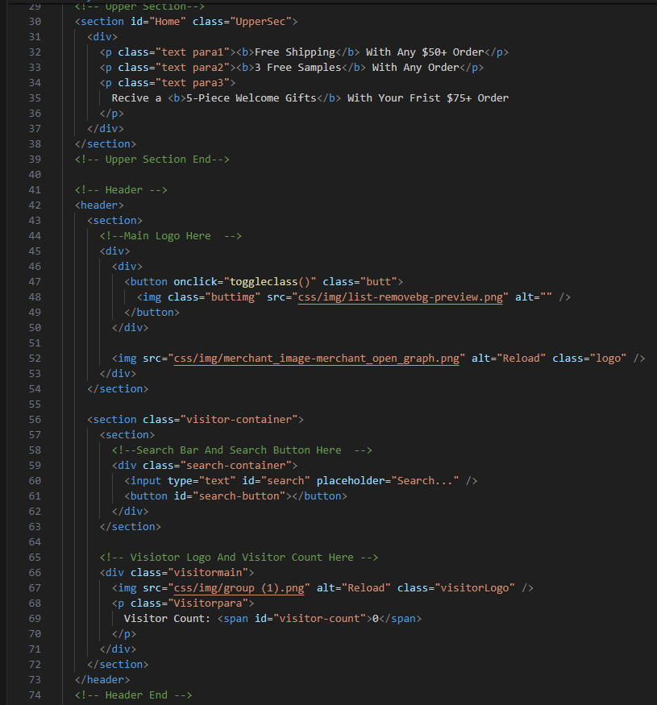

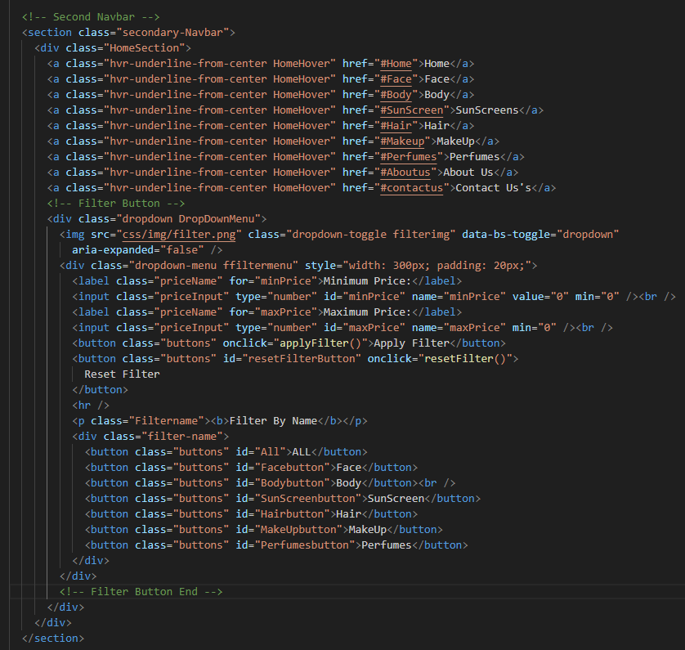

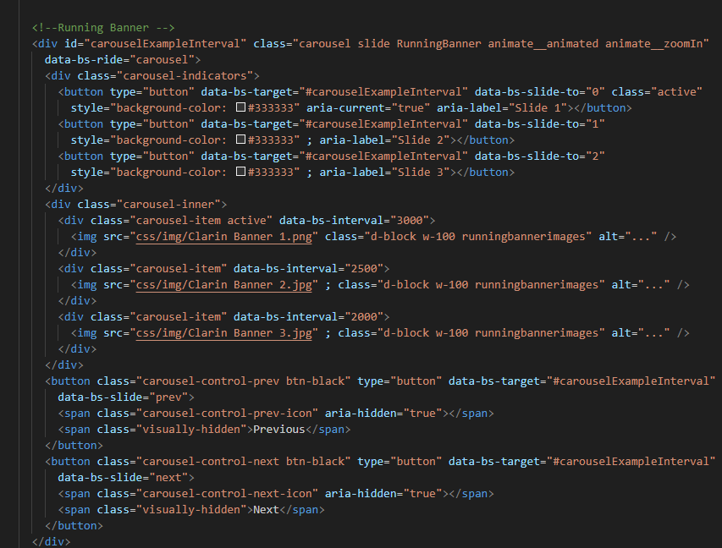

Output

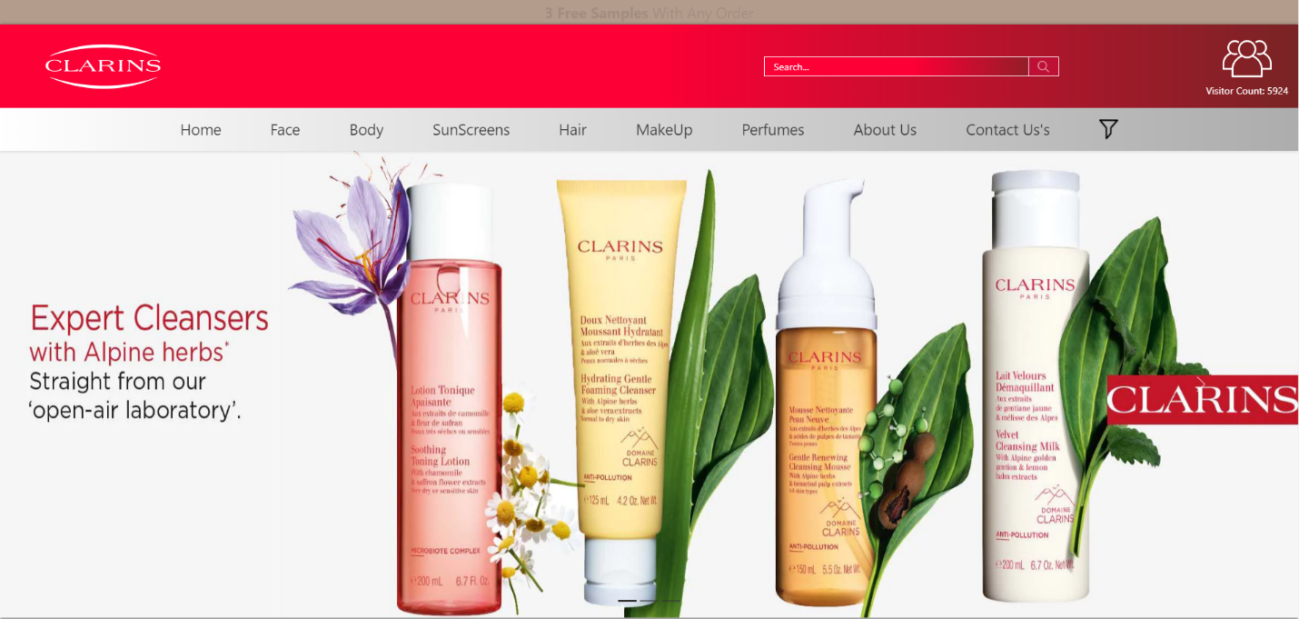

**Description :**

This code is for a website header and navigation bar. The header includes a logo, search bar, and visitor count. The navigation bar consists of links to different sections of the website, a filter button to sort products, and a running banner. The code is written in HTML, CSS, and Bootstrap, and uses JavaScript for functionality such as the filter button and running banner.

* The site must contain various sections like FACE, BODY, SUNSCREEN, HAIR, MAKEUP, PERFUMES etc. with products displayed in these sections.

Source Code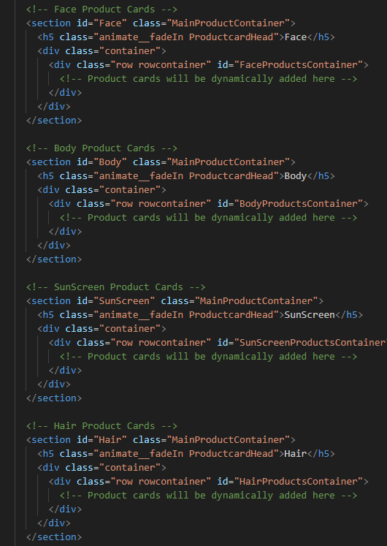

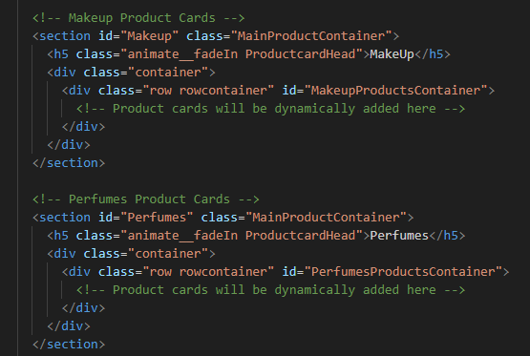

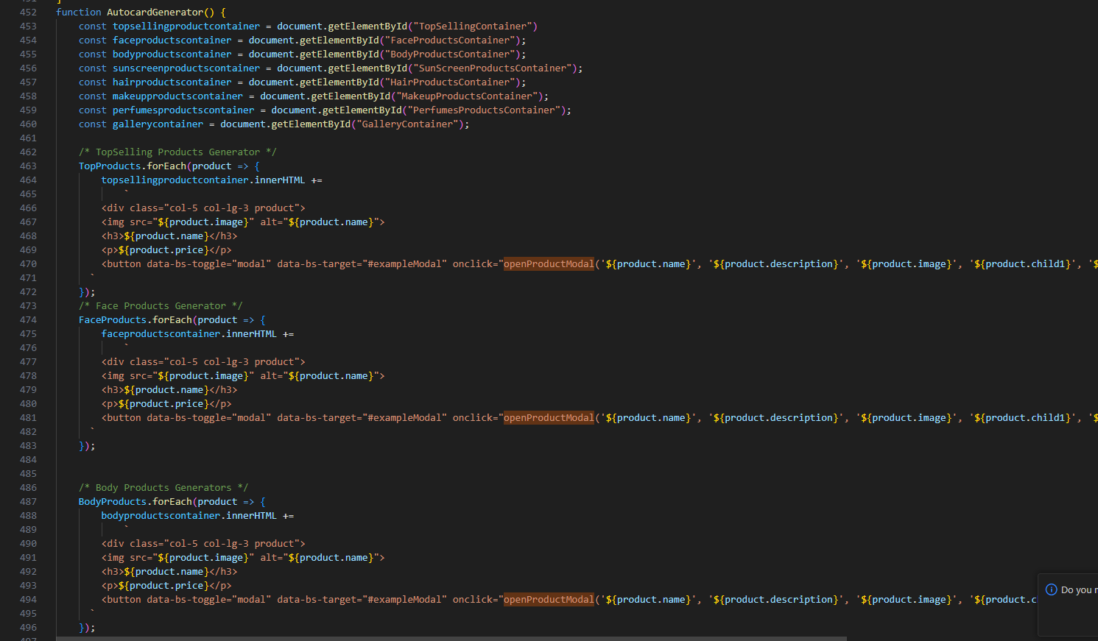

Output

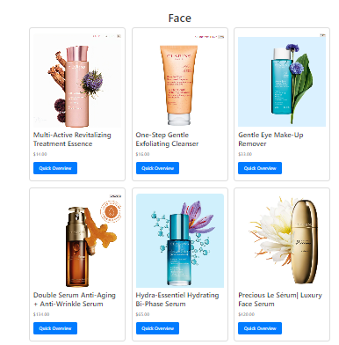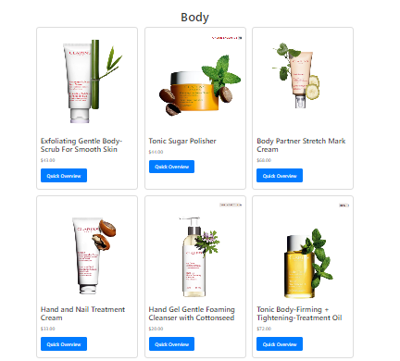

**Description :**

This code is for displaying product cards for different categories such as Face, Body, SunScreen, Hair, and MakeUp. The product cards will be dynamically added to the respective containers using JavaScript. The code uses HTML, CSS, and Bootstrap to create the layout and design of the product cards.

* Clicking on a product should open pop-up window with details and price of the product along with scrollable images.

Source Code

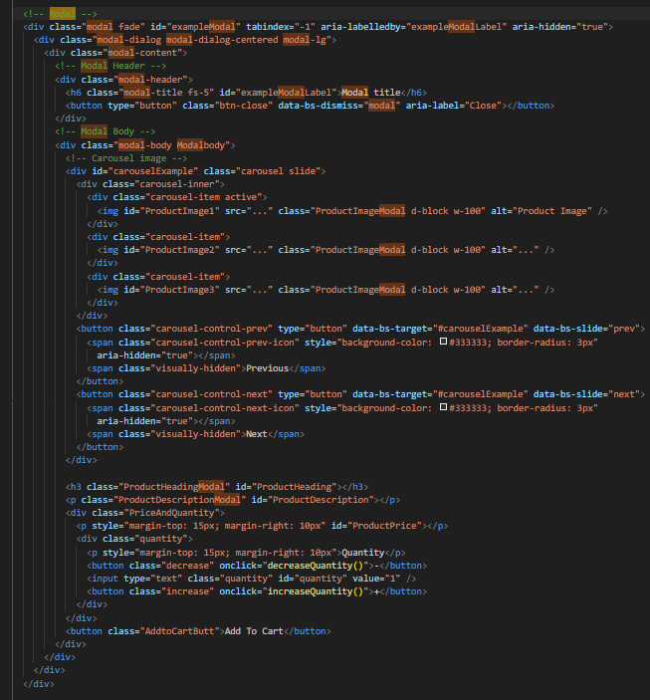

Output

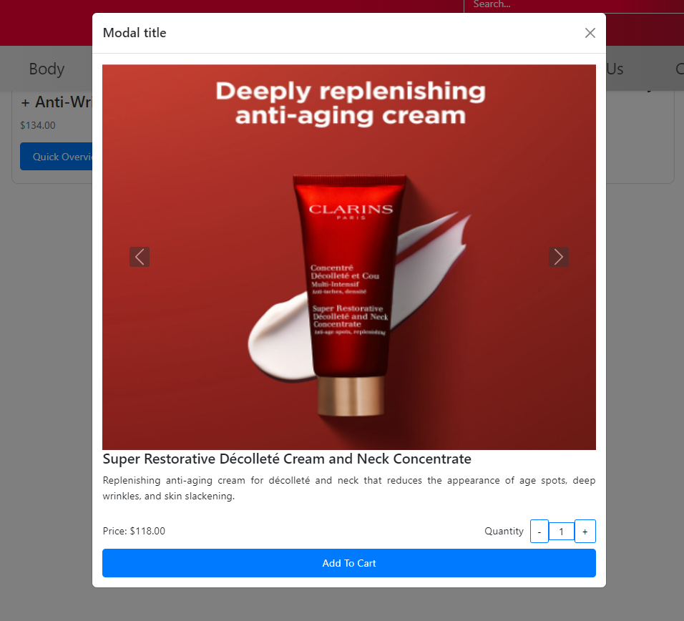

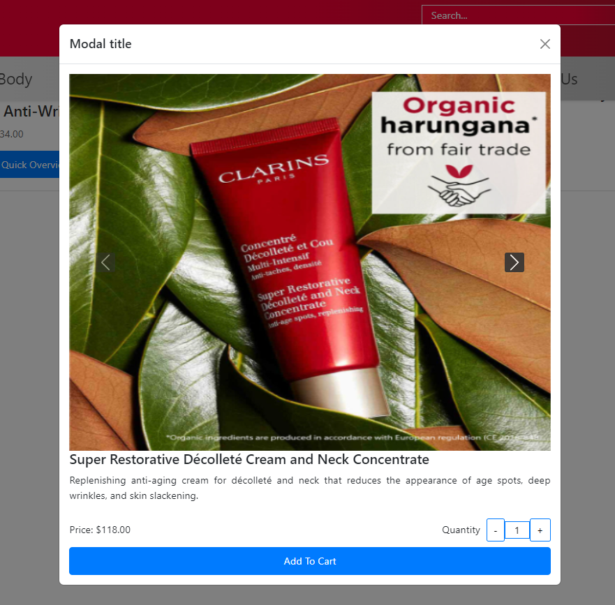

**Description:**

This code is for a modal that displays product details such as images, heading, description, price, and quantity. The modal is triggered by a button or link and is built using Bootstrap. The product details are dynamically loaded into the modal using JavaScript, allowing for different products to be displayed based on user interaction.

* Filters on price, type of products etc. should be provided.

Source Code

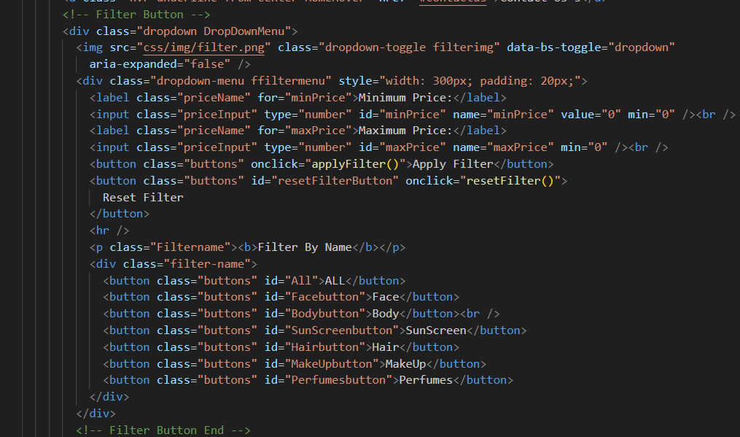

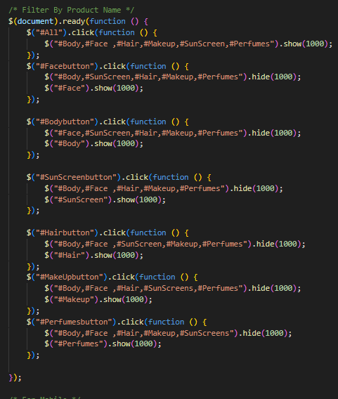

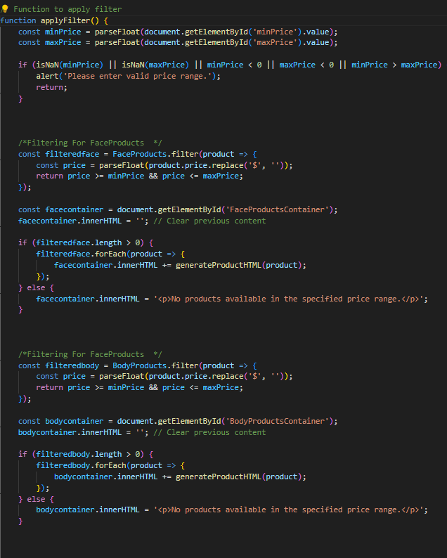

Output

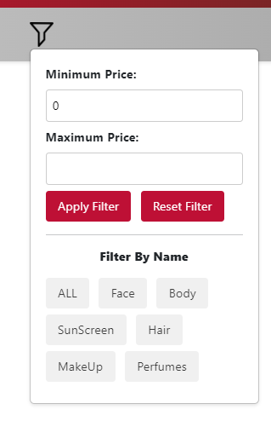

**Description:**

This code creates a dropdown filter menu with options to filter products by name (ALL, Face, Body, SunScreen, Hair, MakeUp, Perfumes) and by price range (Minimum Price and Maximum Price). The "Apply Filter" button applies the selected filters, and the "Reset Filter" button resets all filters to their default values.

* Section on various offers on the product should also be provided.

Source Code

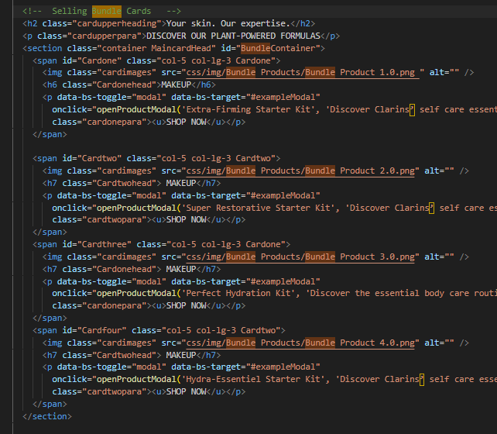

Output

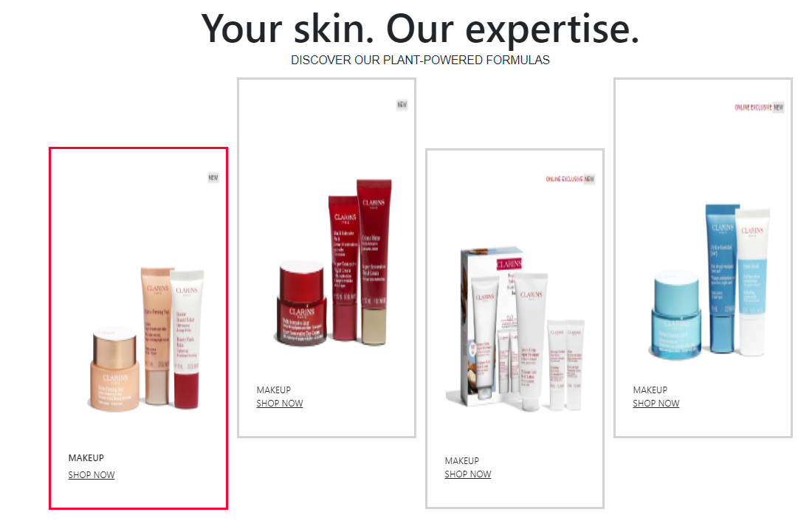

**Description:**

This code creates a section with four product cards, each displaying an image, a header, and a paragraph with a "SHOP NOW" link. The "SHOP NOW" link opens a modal with product details, including the product name, description, and price. The product images and details are dynamically loaded using JavaScript functions. The cards are arranged in a responsive grid using Bootstrap classes.

* Top Selling products should be provided on the Top Section.

Source Code

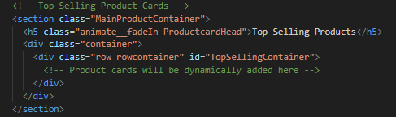

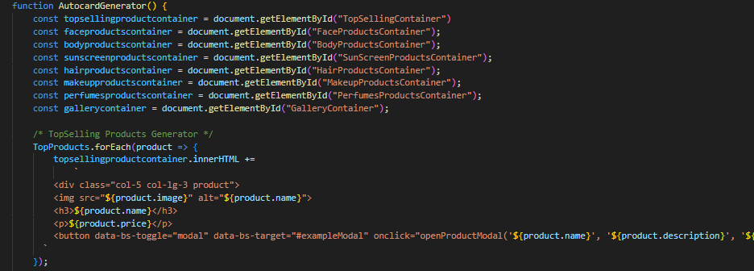

Output

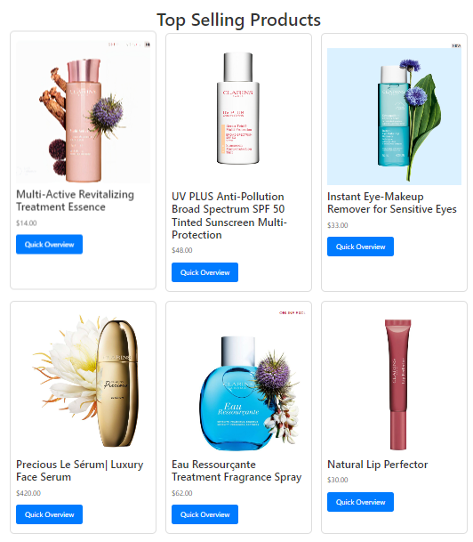

**Description:** This code creates a container for displaying top-selling product cards. The cards will be dynamically loaded and added to the "TopSellingContainer" div using JavaScript or a server-side language. The container is styled using Bootstrap classes for a responsive grid layout. The header "Top Selling Products" is animated using the animate.css library.

* Gallery can be added for viewing different images.

Source Code

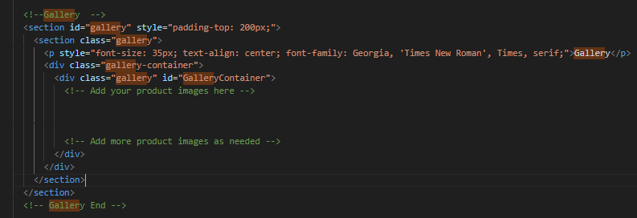

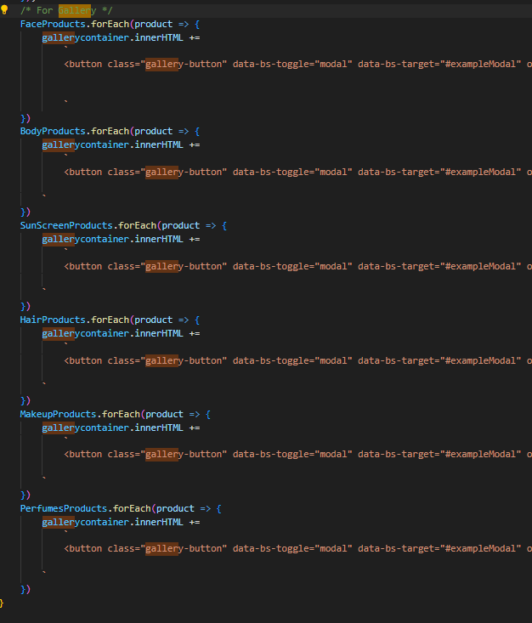

Output

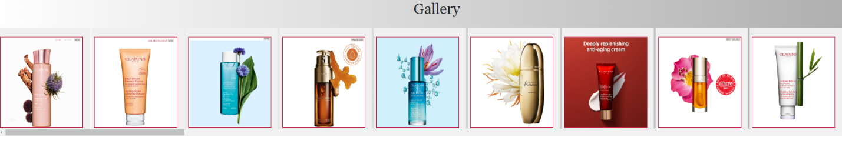

**Description:**

This code creates a section for displaying a product gallery. The gallery container holds multiple product images that will be added dynamically using JavaScript or a server-side language. The container is styled using Bootstrap classes for a responsive grid layout. The header "Gallery" is centered and styled using CSS.

* Site map, Gallery, About us, Contact us link must be added.

Source Code

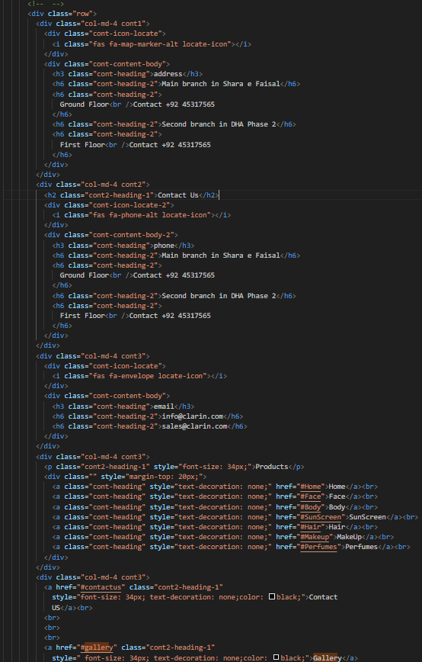

Output

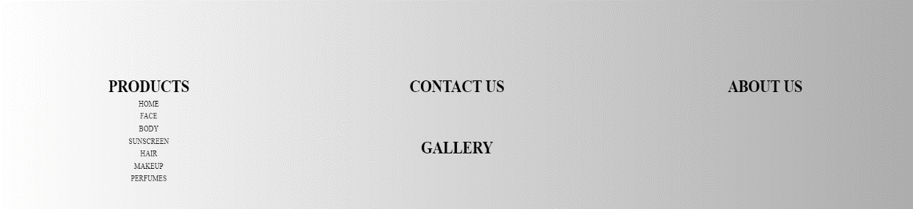

**Description:**

This code creates a row of three columns displaying links to different sections of the website. The columns are styled using Bootstrap classes for responsive layout. The first column contains links to the "Products" section with sub-links to different product categories. The second column contains links to the "Contact Us" and "Gallery" sections. The third column contains a link to the "About Us" section. The links are styled using CSS for consistent appearance.

* Contact Us: This menu option should display Email id, address, and contact number of the organization.

Source Code

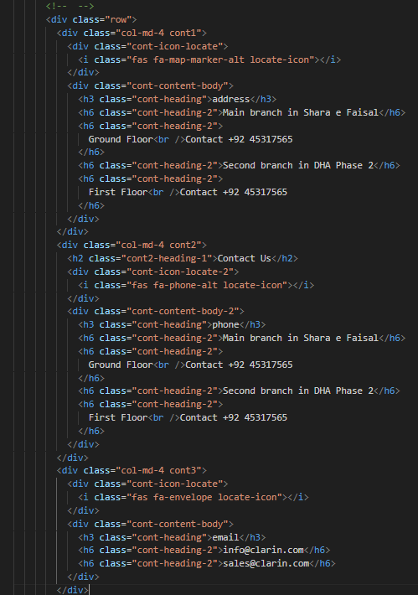

Output

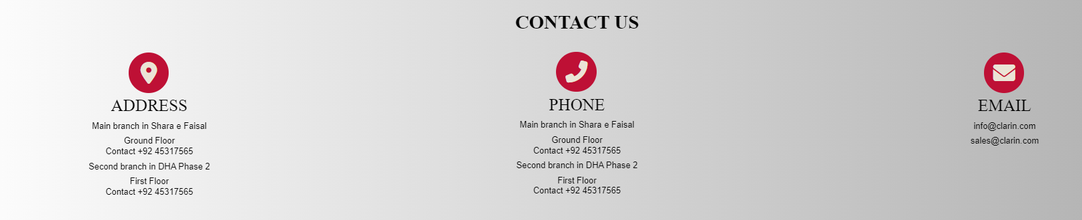

**Description:**

This code creates a row of three columns displaying contact information for a business. The columns are styled using Bootstrap classes for responsive layout. The first column contains the business address with branch locations and contact numbers. The second column contains the business phone numbers with branch contact information. The third column contains the business email addresses. The contact information is styled using CSS for consistent appearance. The Font Awesome icons are used to represent the address, phone, and email.

Over and above this, the portal should implement the following functionalities:

* Display a continuous scrolling ticker at the bottom of the page with current date, time, and location (hint: Use geolocation features of HTML5).
* Display a visitor count at the top right corner of the page beside a logo image.
* The menu options should change color on hover and also after clicking.
* Fade in and fade out options can be used for the menus.

**PROJECT ANALYSIS**

|  |  |
| --- | --- |
| NAME | ENROLLMENT NO |
| Shah Muhammad Siddiqui | Student1528119 |
| TEACHER: SIR SHAHBUDDIN | BATCH CODE:PR2-202310B1 |

